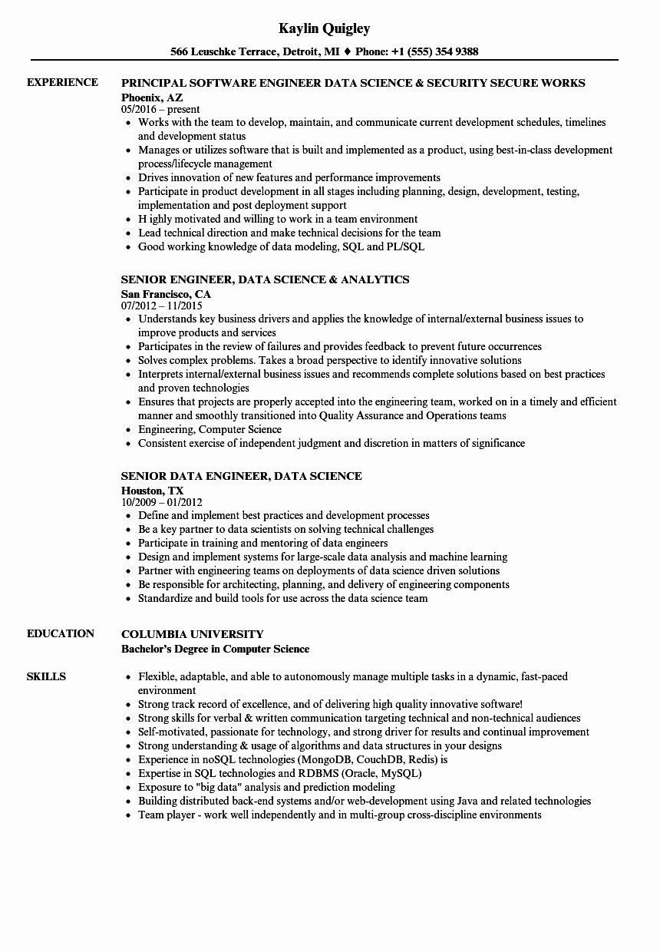
EXPERIENCE
EDUCATION
SKILLS
Kaylin Quigley
566 Leuschke Terrace, Detroit, MI ♦ Phone: +1 (555) 354 9388
PRINCIPAL SOFTWARE ENGINEER DATA SCIENCE & SECURITY SECURE WORKS Phoenix, AZ
05/2016-present
• Works with the team to develop, maintain, and communicate current development schedules, timelines and development status
• Manages or utilizes software that is built and implemented as a product, using best-in-class development process/lifecycle management
⚫ Drives innovation of new features and performance improvements
• Participate in product development in all stages including planning, design, development, testing, implementation and post deployment support
⚫ Highly motivated and willing to work in a team environment
• Lead technical direction and make technical decisions for the team
• Good working knowledge of data modeling, SQL and PL/SQL
SENIOR ENGINEER, DATA SCIENCE & ANALYTICS
San Francisco, CA
07/2012 11/2015
• Understands key business drivers and applies the knowledge of internal/external business issues to improve products and services
• Participates in the review of failures and provides feedback to prevent future occurrences
• Solves complex problems. Takes a broad perspective to identify innovative solutions
• Interprets internal/external business issues and recommends complete solutions based on best practices and proven technologies
• Ensures that projects are properly accepted into the engineering team, worked on in a timely and efficient manner and smoothly transitioned into Quality Assurance and Operations teams
• Engineering, Computer Science
• Consistent exercise of independent judgment and discretion in matters of significance
SENIOR DATA ENGINEER, DATA SCIENCE
Houston, TX
10/2009-01/2012
• Define and implement best practices and development processes
• Be a key partner to data scientists on solving technical challenges
• Participate in training and mentoring of data engineers
• Design and implement systems for large-scale data analysis and machine learning
• Partner with engineering teams on deployments of data science driven solutions
• Be responsible for architecting, planning, and delivery of engineering components
• Standardize and build tools for use across the data science team
COLUMBIA UNIVERSITY
Bachelor's Degree in Computer Science
• Flexible, adaptable, and able to autonomously manage multiple tasks in a dynamic, fast-paced environment
• Strong track record of excellence, and of delivering high quality innovative software!
• Strong skills for verbal & written communication targeting technical and non-technical audiences
⚫ Self-motivated, passionate for technology, and strong driver for results and continual improvement
• Strong understanding & usage of algorithms and data structures in your designs
• Experience in noSQL technologies (MongoDB, CouchDB, Redis) is
• Expertise in SQL technologies and RDBMS (Oracle, MySQL)
• Exposure to "big data" analysis and prediction modeling
• Building distributed back-end systems and/or web-development using Java and related technologies Team player - work well independently and in multi-group cross-discipline environments

